Министерство образования Республики Беларусь

Учреждение образования

«Белорусский государственный университет

информатики и радиоэлектроники»

Факультет компьютерных систем и сетей

Кафедра информатики

Дисциплина: Методы численного анализа

**ОТЧЁТ**

к лабораторной работе

на тему

Решение краевых задач. Метод коллокаций, наименьших квадратов и Галеркина, стрельбы и разностных аппроксимаций

Выполнил: студентка группы 153501

Тимофеев Кирилл Андреевич

Проверил: Анисимов Владимир Яковлевич

Минск 2023

**СОДЕРЖАНИЕ**

1. ВВЕДЕНИЕ………………………………………………………………..3
2. КРАТКИЕ ТЕОРЕТИЧЕСКИЕ СВЕДЕНИЯ………………………….....4
3. ПРОГРАММНАЯ РЕАЛИЗАЦИЯ……………………………………….8

3.1 Код программы………………………………………………………..8

3.2 Результаты…………………………………………………………….10

4. АНАЛИЗ ПОЛУЧЕННЫХ РЕЗУЛЬТАТОВ…………………………….13

**1.** **ВВЕДЕНИЕ**

***Цели выполнения задания***:

- изучить метод коллокаций, наименьших квадратов и Галеркина, стрельбы и разностных аппроксимаций;

- написать программу для решения поставленных задач;

- решить тестовые примеры.

**2.** **КРАТКИЕ ТЕОРЕТИЧЕСКИЕ СВЕДЕНИЯ**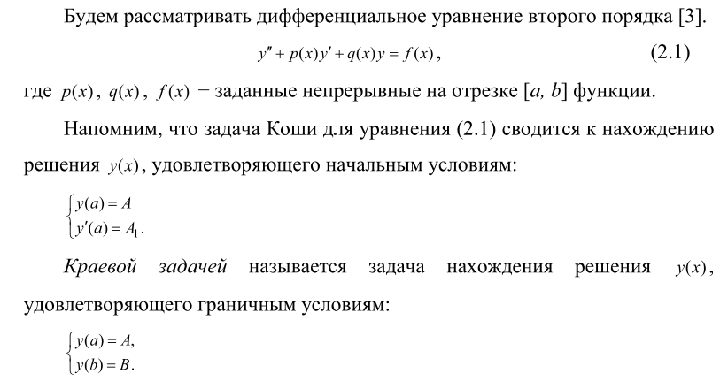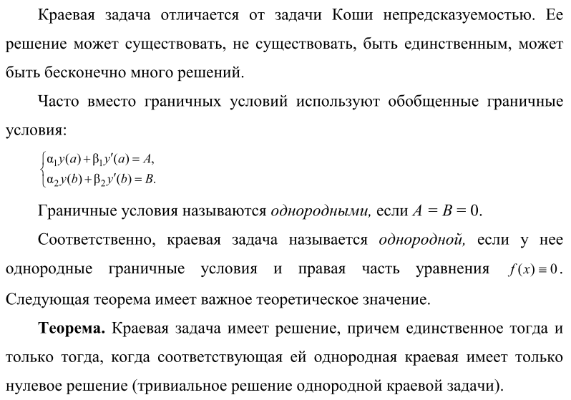

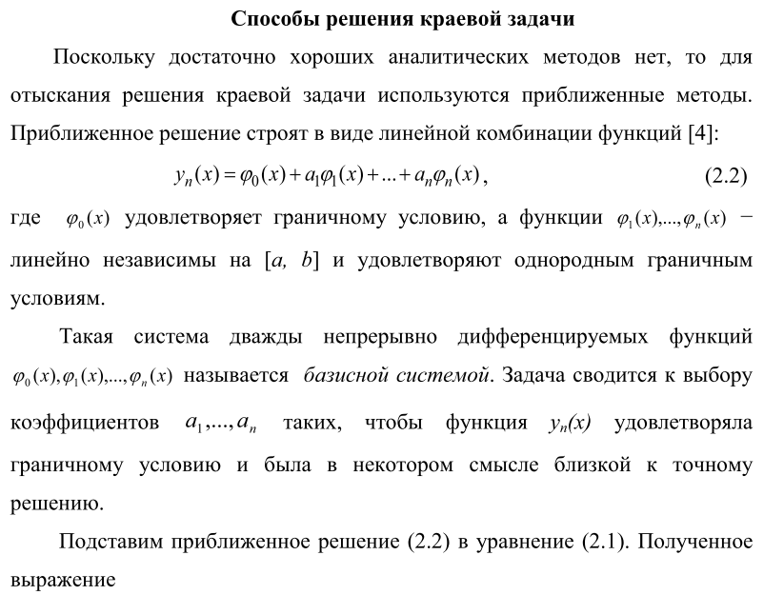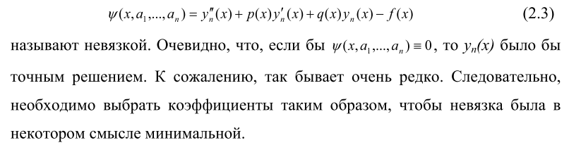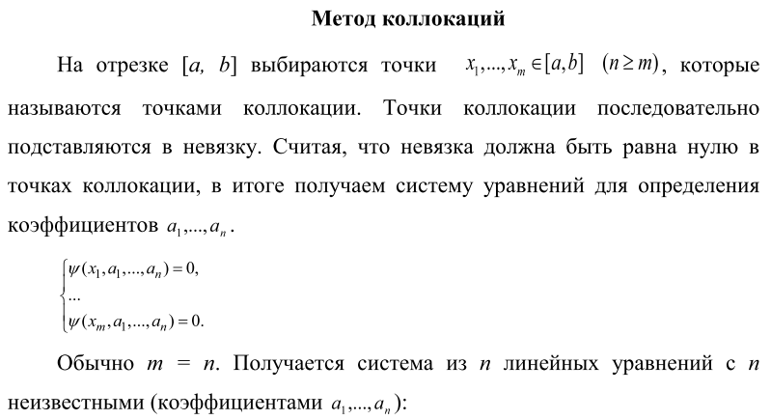

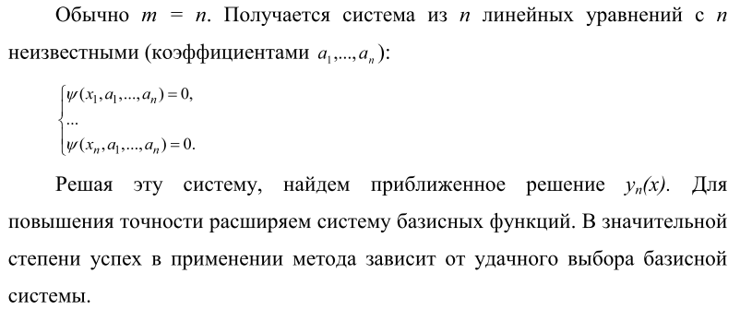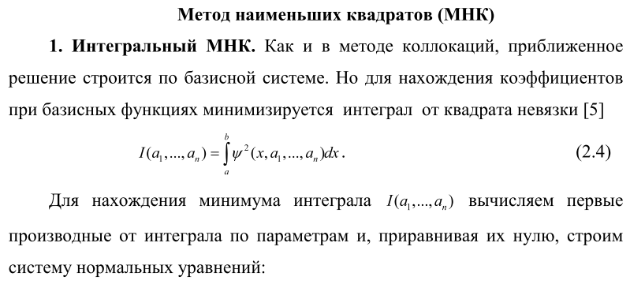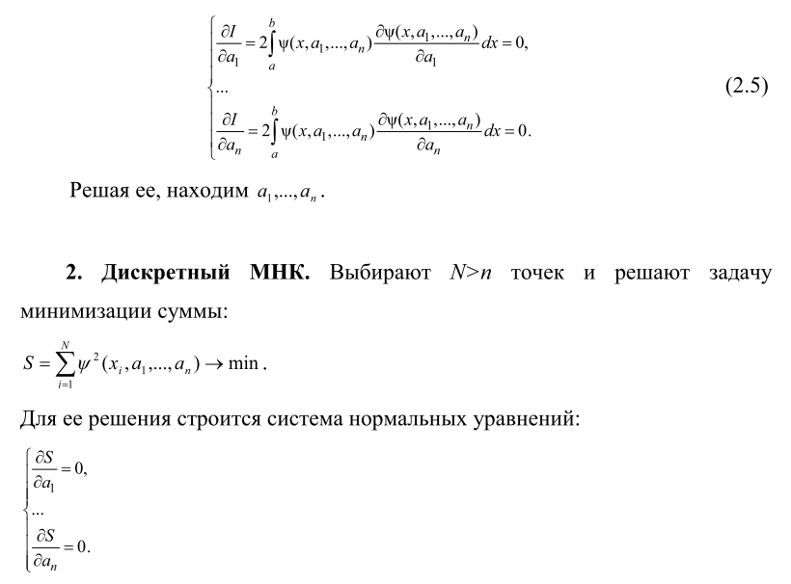

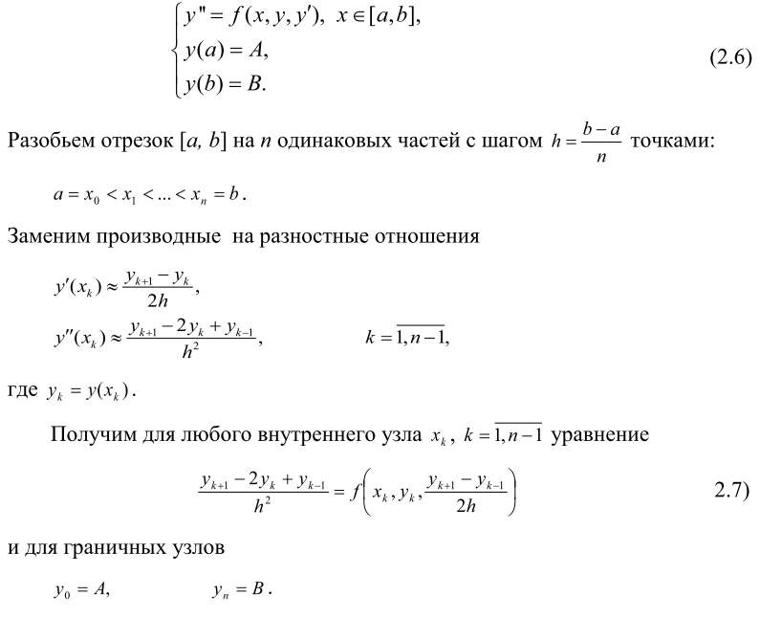

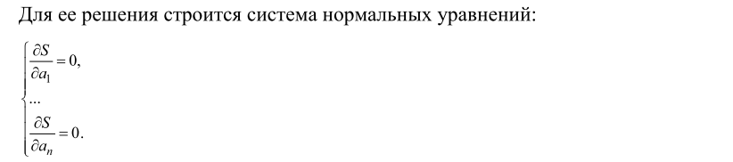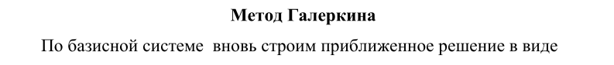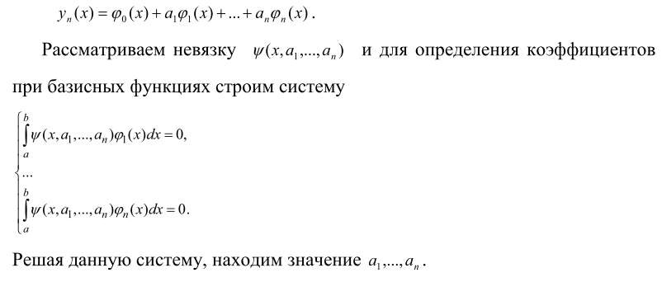

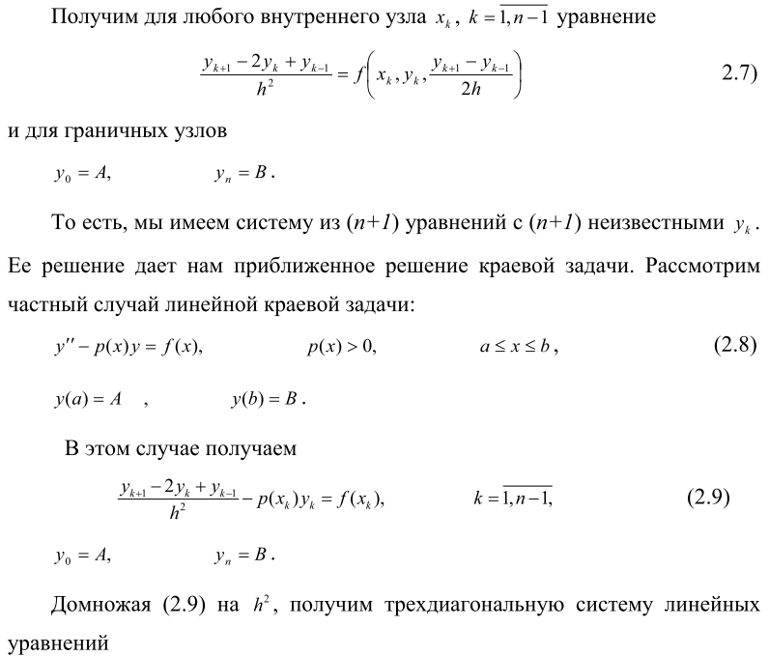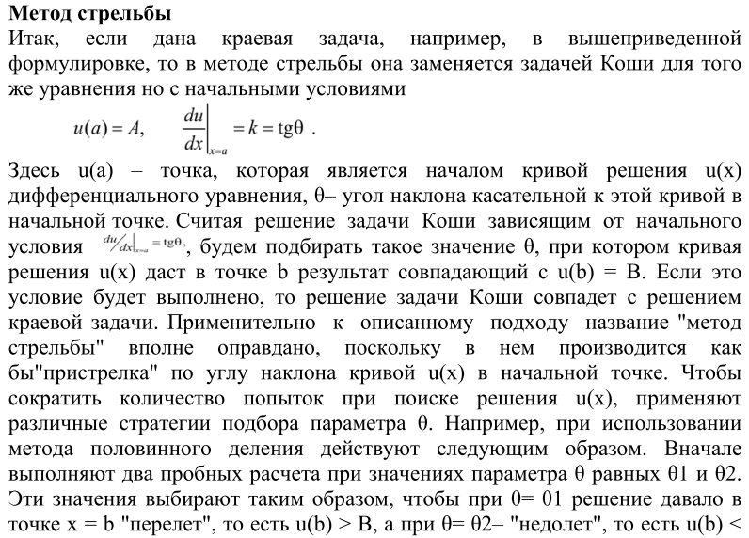

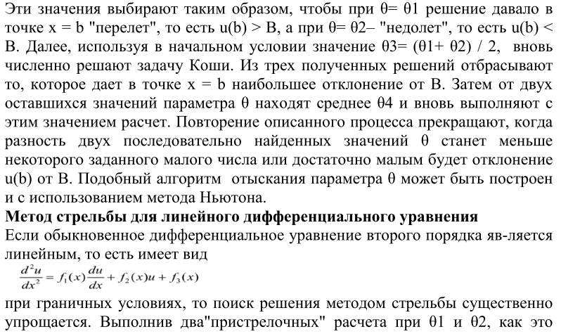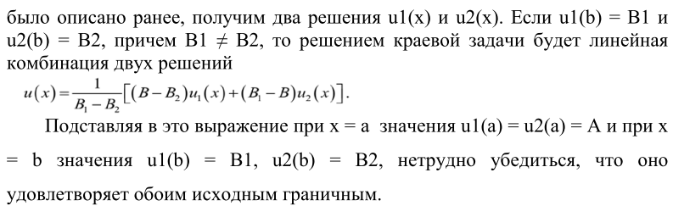

1. **ПРОГРАММНАЯ РЕАЛИЗАЦИЯ**
   1. **Код программы**

main.py

from collocation_method import collocations_method  
from galerkin_method import galerkin_method  
from min_squares_methods import integral_least_square_method, discrete_least_square_method  
from additional_functions import generate_basis_sequence  
from constants import *  
from difference_method import task2, task3_1, task3_2, task5, task6, task7  
from shooting_method import task4  
  
  
# 1.)  
print('collocations method: \n',  
 collocations_method(generate_basis_sequence(3), [-1/2, 0, 1/2]))  
# print('collocations method: \n',  
# collocations_method(generate_basis_sequence(3), [-1/2, 0, 1/2]))  
print('galerkin method: \n',  
 galerkin_method(generate_basis_sequence(3), a, b))  
print('integral lsm method: \n',  
 integral_least_square_method(generate_basis_sequence(N), a, b))  
print('discrete lsm method: \n',  
 discrete_least_square_method(generate_basis_sequence(N), N + 1, a, b))  
  
# 2.)  
task2()  
  
# 3.)  
task3_1()  
task3_2()  
  
# 4.)  
task4()  
  
# 5.)  
task5()  
  
# 6.)  
task6()  
  
# 7.)  
task7()

collocation_method.py

from sympy import linsolve  
from constants import x  
from additional_functions import build_function_from_basis, func_for_substantiation  
import sympy  
  
def collocations_method(basis, points):  
 func = build_function_from_basis(basis)  
 psi_func = func_for_substantiation(func)  
 symbols = [sympy.Symbol('a' + str(i)) for i in range(len(points))]  
 lin_system = []  
 for point in points:  
 lin_system.append(psi_func.subs(x, point).evalf())  
 answer = linsolve(lin_system, *symbols)  
 return answer

additional_functions.py

from constants import *  
import sympy  
  
def func_for_substantiation(subs):  
 func = sympy.sin(k) * sympy.diff(subs, x, x) + ((1 + sympy.cos(k) * x ** 2) * subs + 1)  
 return func  
# def func_for_substantiation(subs):  
# func = sympy.diff(subs, x, x) + ((1 + x ** 2) * subs + 1)  
# return func  
  
def generate_basis_sequence(n):  
 sequence = []  
 for i in range(n):  
 sequence.append((x ** i) * (1 - x ** 2))  
 return sequence  
  
def build_function_from_basis(basis):  
 result = 0  
 for i in range(len(basis)):  
 current_a = sympy.Symbol('a' + str(i))  
 result += current_a * basis[i]  
 return result

constants.py

import sympy as sp  
  
x = sp.Symbol('x')  
  
N = 3  
a = -1  
b = 1  
k = 2  
epsilon = 0.001

difference_method.py

import math  
from abc import abstractmethod  
from math import *  
from kostily import kostil1  
import matplotlib.pyplot as plt  
import numpy as np  
from kostily import kostil2  
  
class Metrics:  
 @staticmethod  
 def l_1_norm(first_vector, second_vector):  
 return np.sum(np.abs(first_vector - second_vector))  
  
 @staticmethod  
 def l_2_norm(first_vector, second_vector):  
 return np.sum((first_vector - second_vector) ** 2)  
  
 @staticmethod  
 def l_infinity_norm(first_vector, second_vector):  
 return np.max(np.abs(first_vector - second_vector))  
  
def solve_tridigional_matrix(upper_diagonal, middle_diagonal, lower_diagonal, result_vector):  
 c_prime = np.zeros(middle_diagonal.size - 1)  
 d_prime = np.zeros(middle_diagonal.size)  
  
 c_prime[0] = upper_diagonal[0] / middle_diagonal[0]  
 for i in range(1, middle_diagonal.size - 1):  
 c_prime[i] = upper_diagonal[i] / (  
 middle_diagonal[i] - lower_diagonal[i - 1] * c_prime[i - 1]  
 )  
  
 d_prime[0] = result_vector[0] / middle_diagonal[0]  
 for i in range(1, middle_diagonal.size):  
 d_prime[i] = (result_vector[i] - lower_diagonal[i - 1] * d_prime[i - 1]) / (  
 middle_diagonal[i] - lower_diagonal[i - 1] * c_prime[i - 1]  
 )  
  
 solution = np.zeros(middle_diagonal.size)  
 solution[-1] = d_prime[-1]  
  
 for i in reversed(range(middle_diagonal.size - 1)):  
 solution[i] = d_prime[i] - c_prime[i] * solution[i + 1]  
 return solution  
  
class AbstractDifferenceSchemeSolver:  
 def *__init__*(  
 self,  
 p_function,  
 q_function,  
 f_function,  
 left_bound,  
 right_bound,  
 h=0.1,  
 amount_points=None,  
 left_condition=None,  
 right_condition=None,  
 ):  
 self.p = p_function  
 self.q = q_function  
 self.f = f_function  
  
 self.left_condition = left_condition  
 self.right_condition = right_condition  
  
 self.left_bound = left_bound  
 self.right_bound = right_bound  
  
 if (  
 amount_points is not None  
 and left_condition is not None  
 and right_condition is not None  
 ):  
 self.set_h((right_bound - left_bound) / (amount_points - 1))  
 elif h is not None:  
 self.set_h(h)  
 else:  
 raise ValueError  
  
 def set_h(self, new_h):  
 self.h = new_h  
 self.x_points = np.arange(self.left_bound, self.right_bound + self.h, self.h)  
 self.y_points = None  
  
 @abstractmethod  
 def _get_difference_scheme_vectors(self):  
 raise NotImplemented  
  
 def get_accuracy(self, metrics):  
 if self.y_points is None:  
 raise ValueError  
 double_h_solver = self.__class__(  
 self.p,  
 self.q,  
 self.f,  
 self.left_bound,  
 self.right_bound,  
 h=self.h * 2.0,  
 left_condition=self.left_condition,  
 right_condition=self.right_condition,  
 )  
 double_h_solver.solve()  
 return metrics(  
 self.y_points[::2],  
 double_h_solver.y_points  
 if self.y_points.size % 2 == 1  
 else double_h_solver.y_points[:-1],  
 ) / (2 ** self._order - 1)  
  
 def get_solution_according_accuracy(  
 self, metrics=Metrics.l_infinity_norm, eps=0.001, step=0.001  
 ):  
 current_accuracy = self.get_accuracy(metrics)  
 while current_accuracy >= eps:  
 self.set_h(self.h - step)  
 self.solve()  
 current_accuracy = self.get_accuracy(metrics)  
 return self.h, current_accuracy  
  
 def solve(self):  
 self.y_points = solve_tridigional_matrix(*self._get_difference_scheme_vectors())  
  
 def plot_solution(self):  
 plt.plot(self.x_points, self.y_points, color='deeppink')  
  
  
class SecondOrderSchemeSolver(AbstractDifferenceSchemeSolver):  
 def *__init__*(  
 self,  
 p_function,  
 q_function,  
 f_function,  
 left_bound,  
 right_bound,  
 h=0.1,  
 amount_points=None,  
 left_condition=None,  
 right_condition=None,  
 ):  
 super().*__init__*(  
 p_function,  
 q_function,  
 f_function,  
 left_bound,  
 right_bound,  
 h=h,  
 amount_points=amount_points,  
 left_condition=left_condition,  
 right_condition=right_condition,  
 )  
 self._order = 2  
  
 def _get_difference_scheme_vectors(self):  
 diagonal = np.ones(self.x_points.size)  
 upper_diagonal = np.zeros(self.x_points.size - 1)  
 lower_diagonal = np.zeros(self.x_points.size - 1)  
  
 diagonal[1:-1] = np.vectorize(lambda x: (self.h ** 2) * self.q(x) - 2)(  
 self.x_points[1:-1]  
 )  
 upper_diagonal[1:] = np.vectorize(lambda x: 1 + self.h * self.p(x) / 2.0)(  
 self.x_points[1:-1]  
 )  
 lower_diagonal[:-1] = np.vectorize(lambda x: 1 - self.h * self.p(x) / 2.0)(  
 self.x_points[1:-1]  
 )  
  
 result = (self.h ** 2) * np.vectorize(self.f)(self.x_points)  
 result[0] = (  
 self.left_condition(self.h)  
 if callable(self.left_condition)  
 else self.left_condition  
 )  
 result[-1] = (  
 self.right_condition(self.h)  
 if callable(self.right_condition)  
 else self.right_condition  
 )  
 return upper_diagonal, diagonal, lower_diagonal, result  
  
class SecondOrderSchemeSolverBoundaryConditions(SecondOrderSchemeSolver):  
 def *__init__*(  
 self,  
 p_function,  
 q_function,  
 f_function,  
 left_bound,  
 right_bound,  
 h=0.1,  
 amount_points=None,  
 left_condition=None,  
 right_condition=None,  
 ):  
 super().__init__(  
 p_function,  
 q_function,  
 f_function,  
 left_bound,  
 right_bound,  
 h=h,  
 amount_points=amount_points,  
 left_condition=left_condition[0],  
 right_condition=right_condition[0],  
 )  
 self.left_condition_function = left_condition[1]  
 self.left_condition_derivative_function = left_condition[2]  
  
 self.right_condition_function = right_condition[1]  
 self.right_condition_derivative_function = right_condition[2]  
  
 def get_accuracy(self, metrics):  
 if self.y_points is None:  
 raise ValueError  
 left_condition = (  
 self.left_condition,  
 self.left_condition_function,  
 self.left_condition_derivative_function,  
 )  
 right_condition = (  
 self.right_condition,  
 self.right_condition_function,  
 self.right_condition_derivative_function,  
 )  
  
 double_h_solver = self.__class__(  
 self.p,  
 self.q,  
 self.f,  
 self.left_bound,  
 self.right_bound,  
 h=self.h * 2.0,  
 left_condition=left_condition,  
 right_condition=right_condition,  
 )  
 double_h_solver.solve()  
 return metrics(  
 self.y_points[::2],  
 double_h_solver.y_points  
 if self.y_points.size % 2 == 1  
 else double_h_solver.y_points[:-1],  
 ) / (2 ** self._order - 1)  
  
 def _get_difference_scheme_vectors(self):  
 (  
 upper_diagonal,  
 diagonal,  
 lower_diagonal,  
 result,  
 ) = super()._get_difference_scheme_vectors()  
  
 diagonal[0] = (  
 (-3 / 2.0 + lower_diagonal[0] / (2 * upper_diagonal[1]))  
 * self.left_condition_derivative_function  
 + self.left_condition_function * self.h  
 )  
 upper_diagonal[0] = (  
 2 + diagonal[1] / (2 * upper_diagonal[1])  
 ) * self.left_condition_derivative_function  
 result[0] += (  
 result[1]  
 * self.left_condition_derivative_function  
 / (2 * upper_diagonal[1])  
 )  
  
 lower_diagonal[-1] = (  
 -2 - diagonal[-2] / (2.0 * lower_diagonal[-2])  
 ) * self.right_condition_derivative_function  
 diagonal[-1] = (  
 (3 / 2 - upper_diagonal[-1] / (2.0 * lower_diagonal[-2]))  
 * self.right_condition_derivative_function  
 + self.right_condition_function * self.h  
 )  
 result[-1] -= (  
 result[-2] / (2.0 * lower_diagonal[-2])  
 ) * self.right_condition_derivative_function  
  
 return upper_diagonal, diagonal, lower_diagonal, result  
  
def task2():  
 a = sin(2)  
 b = cos(2)  
 A = 0  
 B = 0  
 eps = 0.001  
 # h = 0.07799999999999963  
 # h = 0.1  
 h = kostil1()  
 solver = SecondOrderSchemeSolver(  
 lambda x: 0,  
 lambda x: (1 + b * x ** 2) / a,  
 lambda x: -1 / a,  
 -1,  
 1,  
 h,  
 left_condition=A,  
 right_condition=B,  
 )  
 solver.solve()  
 solver.plot_solution()  
 solver.get_accuracy(Metrics.l_infinity_norm)  
  
 # h, error = solver.get_solution_according_accuracy(Metrics.l_infinity_norm)  
 # print(f"the step at which accuracy {eps} is achieved, equals {h=}, and {error=}")  
 print(f"\nthe step at which accuracy {eps} is achieved, equals {h=}")  
 plt.title(f"h = {h}\neps = {eps}")  
 plt.xlabel("x")  
 plt.ylabel("y")  
 # solver.plot_solution(mode="smooth")  
 plt.show()  
 plt.title(f"difference with galerkin method")  
 plt.xlabel("x")  
 plt.ylabel("y")  
 solver.plot_solution()  
 x = np.linspace(-1, 1, 1000)  
 plt.plot(x, .963545669335502 * (-(x ** 2) + 1) - .102864438561445 * (x ** 2) * (-(x ** 2) + 1))  
 plt.show()  
  
  
def task3_1():  
 p = lambda x: -x  
 q = lambda x: 2  
 f = lambda x: x + 1  
  
 left_bound = 0.9  
 right_bound = 1.2  
  
 left_condition = (lambda h: 2 * h, 1, -0.5)  
 right_condition = (lambda h: h, 1, 0)  
 eps = 0.001  
  
 solver = SecondOrderSchemeSolverBoundaryConditions(  
 p,  
 q,  
 f,  
 left_bound,  
 right_bound,  
 h=0.1,  
 left_condition=left_condition,  
 right_condition=right_condition,  
 )  
 solver.solve()  
 h, error = solver.get_solution_according_accuracy(Metrics.l_infinity_norm, eps=eps)  
 print(f"the step at which accuracy {eps} is achieved {h=}")  
 plt.title(f"h = {h}\neps = {eps}")  
 plt.xlabel("x")  
 plt.ylabel("y")  
 solver.plot_solution()  
 plt.show()  
  
 # kostil2()  
  
def task3_2():  
 p_test = lambda x: -x / (x - 1)  
 q_test = lambda x: 1 / (x - 1)  
 f_test = lambda x: (x - 1)  
 left_bound = 2  
 left_condition = (lambda h: h * 2, 0, 1)  
 right_bound = 4  
 right_condition = (lambda h: h * 5, 2, 1)  
 analytic_solution = lambda x: -0.072 * exp(x) + 7.532 * x - x ** 2 - x - 1  
 solver = SecondOrderSchemeSolverBoundaryConditions(  
 p_test,  
 q_test,  
 f_test,  
 left_bound,  
 right_bound,  
 amount_points=100,  
 left_condition=left_condition,  
 right_condition=right_condition,  
 )  
 solver.solve()  
 plt.title("test")  
 plt.xlabel("x")  
 plt.ylabel("y")  
 x = np.linspace(2, 4, 1000)  
 plt.plot(x, np.vectorize(analytic_solution)(x), color='black')  
 solver.plot_solution()  
 plt.show()  
  
  
def task5():  
 A = 0  
 B = 5  
 eps = 0.05  
 h = 0.039  
 solver = SecondOrderSchemeSolver(  
 lambda x: -2*x,  
 lambda x: -5*(2+math.sin(2*x))/math.exp(-(x**2)),  
 lambda x: -(math.exp(x)*(1+math.sin(2*x)))/math.exp(-(x**2)),  
 0,  
 2,  
 h,  
 left_condition=A,  
 right_condition=B,  
 )  
 solver.solve()  
 solver.plot_solution()  
 solver.get_accuracy(Metrics.l_infinity_norm)  
  
 # h, error = solver.get_solution_according_accuracy(Metrics.l_infinity_norm)  
 # print(f"the step at which accuracy {eps} is achieved, equals {h=}, and {error=}")  
 print(f"\nthe step at which accuracy {eps} is achieved, equals {h=}")  
 plt.title(f"h = {h}\neps = {eps}")  
 plt.xlabel("x")  
 plt.ylabel("y")  
 solver.plot_solution()  
 plt.show()  
  
  
def task6():  
 p = lambda x: 1  
 q = lambda x: 2*x  
 f = lambda x: x**2 + 1  
  
 left_bound = 0.3  
 right_bound = 2.7  
  
 left_condition = (lambda h: 3 * h, 1, 0.5)  
 right_condition = (lambda h: h, 1, 0)  
 eps = 0.03  
  
 solver = SecondOrderSchemeSolverBoundaryConditions(  
 p,  
 q,  
 f,  
 left_bound,  
 right_bound,  
 h=0.1,  
 left_condition=left_condition,  
 right_condition=right_condition,  
 )  
 solver.solve()  
 h, error = solver.get_solution_according_accuracy(Metrics.l_infinity_norm, eps=eps)  
 print(f"the step at which accuracy {eps} is achieved {h=}")  
 plt.title(f"h = {h}\neps = {eps}")  
 plt.xlabel("x")  
 plt.ylabel("y")  
 solver.plot_solution()  
 plt.show()  
  
  
def task7():  
 p = lambda x: 0  
 q = lambda x: -3.2/0.4  
 f = lambda x: 8*x*(x**2-2)/0.4  
  
 left_bound = 0  
 right_bound = 1.275  
  
 left_condition = (0, 0.5, -0.4)  
 right_condition = (0, 0.5, 0.4)  
 eps = 0.0001  
  
 solver = SecondOrderSchemeSolverBoundaryConditions(  
 p,  
 q,  
 f,  
 left_bound,  
 right_bound,  
 h=0.1,  
 left_condition=left_condition,  
 right_condition=right_condition,  
 )  
 solver.solve()  
 h, error = solver.get_solution_according_accuracy(Metrics.l_infinity_norm, eps=eps)  
 print(f"the step at which accuracy {eps} is achieved {h=}")  
 plt.title(f"h = {h}\neps = {eps}")  
 plt.xlabel("x")  
 plt.ylabel("y")  
 solver.plot_solution()  
  
 p = lambda x: 0  
 q = lambda x: -12 / 0.4  
 f = lambda x: 8 * x * (x ** 2 - 2) / 1.4  
  
 left_bound = 1.275  
 right_bound = 1.8  
  
 left_condition = (0, 0.5, -1.4)  
 right_condition = (0, 0.5, 1.4)  
 eps = 0.0001  
  
 solver = SecondOrderSchemeSolverBoundaryConditions(  
 p,  
 q,  
 f,  
 left_bound,  
 right_bound,  
 h=0.1,  
 left_condition=left_condition,  
 right_condition=right_condition,  
 )  
 solver.solve()  
 h, error = solver.get_solution_according_accuracy(Metrics.l_infinity_norm, eps=eps)  
 print(f"the step at which accuracy {eps} is achieved {h=}")  
 plt.title(f"h = {h}\neps = {eps}")  
 plt.xlabel("x")  
 plt.ylabel("y")  
 solver.plot_solution()  
  
 plt.show()

galerkin_method.py

from sympy import linsolve  
from constants import *  
from additional_functions import build_function_from_basis, func_for_substantiation  
import sympy  
  
  
def galerkin_method(basis, A, B):  
 func = build_function_from_basis(basis)  
 # print(f"Functions from basics: {func}")  
 psi_func = func_for_substantiation(func)  
 symbols = [sympy.Symbol('a' + str(i)) for i in range(len(basis))]  
 lin_system = []  
 for i in range(len(basis)):  
 lin_system.append(sympy.integrate(  
 psi_func * basis[i], (x, A, B)).evalf())  
 answer = linsolve(lin_system, *symbols)  
 return answer

kostily.py

import math  
import numpy as np  
import matplotlib.pyplot as plt  
  
def sweep_method(a, b, c, d):  
 AlphaS = [-c[0] / b[0]]  
 BetaS = [d[0] / b[0]]  
 GammaS = [b[0]]  
 n = len(d)  
 result = [0 for i in range(n)]  
 for i in range(1, n - 1):  
 GammaS.append(b[i] + a[i] * AlphaS[i - 1])  
 AlphaS.append(-c[i] / GammaS[i])  
 BetaS.append((d[i] - a[i] * BetaS[i - 1]) / GammaS[i])  
 GammaS.append(b[n - 1] + a[n - 1] * AlphaS[n - 2])  
 BetaS.append((d[n - 1] - a[n - 1] * BetaS[n - 2]) / GammaS[n - 1])  
 result[n - 1] = BetaS[n - 1]  
 for i in reversed(range(n - 1)):  
 result[i] = AlphaS[i] * result[i + 1] + BetaS[i]  
 return result  
  
  
def check_eps(current, prev, eps):  
 eps_t = max([math.fabs(current[i * 2] - prev[i]) for i in range(len(prev))])  
 if eps_t > eps:  
 return False  
 return True  
  
  
def deep_copy(system):  
 return [item for item in system]  
  
  
def get_h(a, b, n):  
 return (b - a) / n  
  
  
def kostil1():  
 iteration_count = 0  
 prev = []  
 current = []  
 eps = 1e-3  
 h = 0  
 n = 32  
 A = -1  
 B = 1  
 first = 0  
 last = 0  
 while True:  
 h = get_h(A, B, n)  
 points = list(np.linspace(A, B, n + 2))  
 del points[0]  
 del points[-1]  
 a = [1 for x in points]  
 b = [-(2 + (h ** 2) * (1 + math.sin(2) * (x ** 2)) / math.cos(2)) for x in points]  
 c = [1 for x in points]  
 d = [-(h ** 2) for x in points]  
 d[0] = d[0] - a[0] * first  
 d[-1] = d[-1] - c[-1] * last  
 current = sweep_method(a, b, c, d)  
 if iteration_count != 0 and check_eps(current, prev, eps):  
 break  
 prev = deep_copy(current)  
 iteration_count += 1  
 n *= 2  
 # print("\nh = ", h)  
 return h  
  
  
def kostil2():  
 INTERVAL: tuple = (0.9, 1.2)  
  
 def get_norm(values: list, step: float) -> float:  
 summ: float = 0.0  
  
 for value in values:  
 summ += value * value * step  
  
 return math.sqrt(summ)  
 return max(*values[0:-1])  
  
 def get_3_task_solution_with_number_of_subranges(n: int) -> tuple:  
 step: float = (INTERVAL[1] - INTERVAL[0]) / n  
  
 y_kprev = lambda x: 2 + x * step  
 y_k = lambda x: 0.4 * step * step - 4  
 y_knext = lambda x: 2 - x * step  
  
 b_k = lambda x: (x + 1) * 2 * step * step # for free coefficients vector  
  
 # coefficients matrices with first initial condition already  
 free_coefficients: list[float] = [4 * step]  
 main_coefficients: list[list[float]] = [[0] * (n + 1)]  
 main_coefficients[0][0] = 2 * step + 1.5  
 main_coefficients[0][1] = -2  
 main_coefficients[0][2] = 0.5  
  
 x_array: list[float] = [INTERVAL[0]]  
  
 for k in range(1, n):  
 new_row: list[float] = [0] * (n + 1)  
 new_row[k - 1] = y_kprev(x_array[-1])  
 x_array.append(x_array[-1] + step)  
 new_row[k] = y_k(x_array[-1])  
 new_row[k + 1] = y_knext(x_array[-1] + step)  
  
 main_coefficients.append(new_row)  
 free_coefficients.append(b_k(x_array[-1]))  
  
 x_array.append(INTERVAL[1])  
  
 main_coefficients.append([0] * (n + 1))  
 main_coefficients[-1][-1] = 1  
 free_coefficients.append(1)  
  
 y_array: list[float] = list(np.linalg.solve(main_coefficients, free_coefficients))  
  
 plt.plot(x_array, y_array, mew=2, ms=10)  
 plt.show()  
  
 return x_array, y_array, get_norm(y_array, step)  
  
 def get_3_task_solution(epsilon: float) -> None:  
 number_of_ranges: int = 3  
  
 first_solution = get_3_task_solution_with_number_of_subranges(number_of_ranges)  
 number_of_ranges *= 2  
 second_solution = get_3_task_solution_with_number_of_subranges(number_of_ranges)  
  
 while abs(first_solution[2] - second_solution[2]) > epsilon:  
 number_of_ranges *= 2  
 first_solution = second_solution  
 second_solution = get_3_task_solution_with_number_of_subranges(number_of_ranges)  
  
 def solve_task3() -> None:  
 epsilon: float = 0.001  
 get_3_task_solution(epsilon)  
  
 solve_task3()  
  
def kostyl3():  
 pass

min_squares_methods.py

import functools  
from numpy import linspace  
from sympy import linsolve  
from constants import *  
from additional_functions import build_function_from_basis, func_for_substantiation  
import sympy  
  
  
def integral_least_square_method(basis, A, B):  
 func = build_function_from_basis(basis)  
 psi_func = func_for_substantiation(func)  
 symbols = [sympy.Symbol('a' + str(i)) for i in range(len(basis))]  
 lin_system = []  
 for i in range(len(basis)):  
 lin_system.append(sympy.integrate(2 * sympy.diff(  
 psi_func, symbols[i]) * psi_func, (x, A, B)).evalf())  
 answer = linsolve(lin_system, *symbols)  
 return answer  
  
  
def discrete_least_square_method(basis, points_num, A, B):  
 func = build_function_from_basis(basis)  
 psi_func = func_for_substantiation(func)  
 seq = [psi_func.subs(x, point) ** 2 for point  
 in linspace(A + 0.05, B - 0.05, points_num)]  
 psi_sqr_sum = functools.reduce((lambda A, B: A + B), seq)  
 symbols = [sympy.Symbol('a' + str(i)) for i in range(len(basis))]  
 lin_system = []  
 for i in range(len(basis)):  
 lin_system.append(sympy.diff(psi_sqr_sum, symbols[i]).evalf())  
 answer = linsolve(lin_system, *symbols)  
 return answer

shooting_method.py

import numpy as np  
from scipy.integrate import solve_ivp  
import matplotlib.pyplot as plt  
  
def test():  
 x = np.linspace(0, 2 * np.pi, 100)  
 y_exact = 7 * np.cos(np.sqrt(3) * x) - 7 * np.cos(2 * np.pi * np.sqrt(3)) / np.sin(2 * np.pi * np.sqrt(3)) * np.sin(  
 np.sqrt(3) * x)  
  
 def equations(x, y):  
 yprime = np.zeros(2)  
  
 yprime[0] = y[1]  
 yprime[1] = -3 * y[0]  
  
 return yprime  
  
 tol = 1e-6  
 max_iters = 100  
 low = -10  
 high = 10  
 count = 0  
  
 while count <= max_iters:  
 count = count + 1  
 xspan = (x[0], x[-1])  
  
 # Use the midpoint between high and low as our guess  
 yprime0 = np.mean([low, high])  
  
 # Set the initial condition vector to be passed into the solver  
 y0 = [7, yprime0]  
  
 # Solve the system using our guess  
 sol = solve_ivp(equations, xspan, y0, t_eval=x)  
  
 # For ease of use, extract the function values from the solution object.  
 y_num = sol.y[0, :]  
  
 # Check to see if we within our desire tolerance  
 if np.abs(y_num[-1]) <= tol:  
 break  
  
 # Adjust our bounds if we are not within tolerance  
 if y_num[-1] < 0:  
 high = yprime0  
 else:  
 low = yprime0  
  
 # print(count, y_num[-1])  
  
 # Plot the solution and compare it to the analytical form defined above  
 plt.plot(x, y_exact, 'k', label='Exact')  
 plt.plot(x, y_num, 'b.', label='Numeric')  
 plt.plot([0, 2 * np.pi], [7, 0], 'bo')  
 plt.grid(True)  
 plt.xlabel('x')  
 plt.ylabel('y')  
 plt.show()  
  
def task4():  
 test()

* 1. **Результаты (Вариант 2)**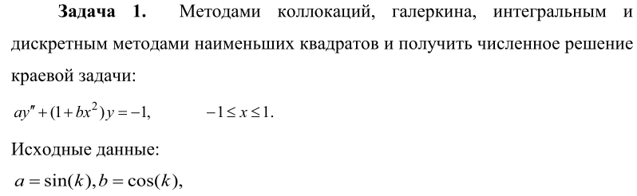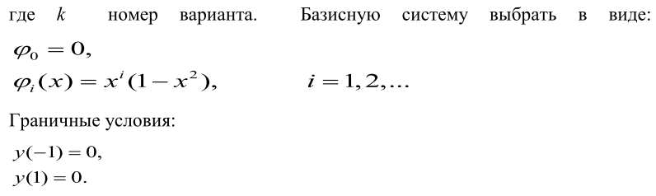

Значения коэффициентов в каждом методе при взятии трёх базисных функций:

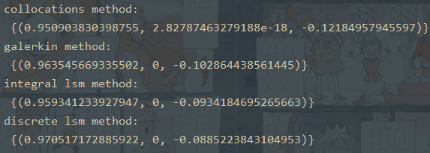

Полученные уравнения: 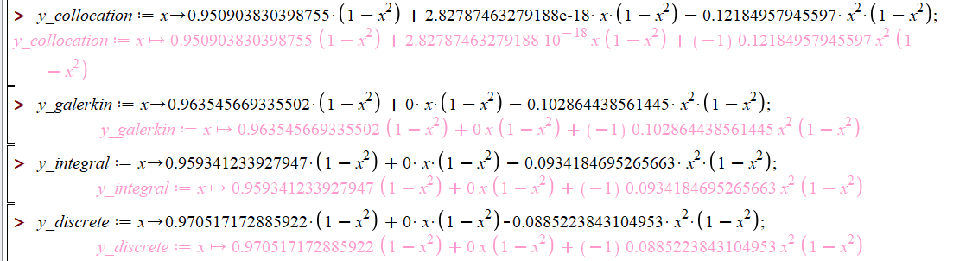

Их графики в одной системе координат (метод коллокаций – коричневый цвет, метод галеркина – голубой цвет, интегральный МНК – красный цвет, дискретный МНК – фиолетовый цвет):

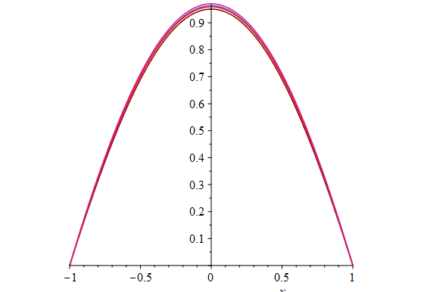

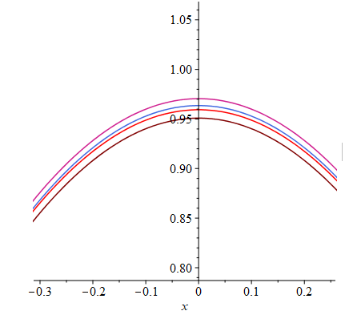

Возьмём тестовый пример из методического пособия: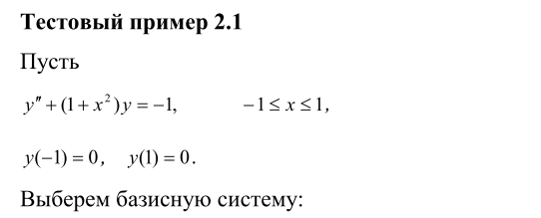

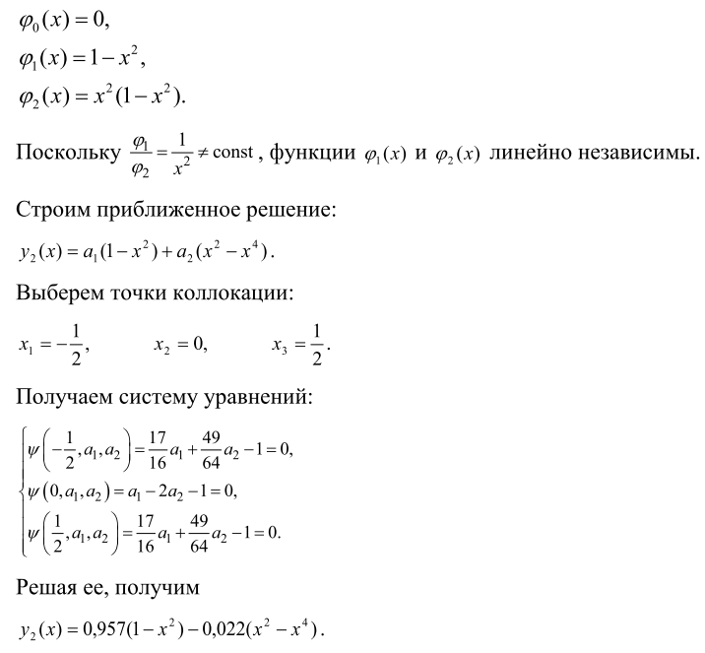



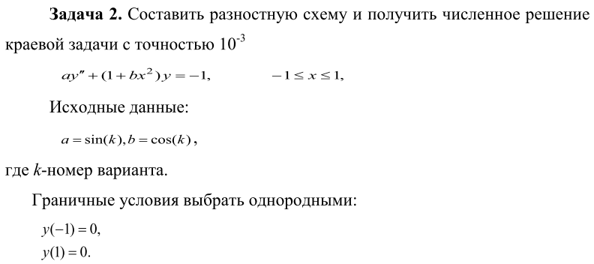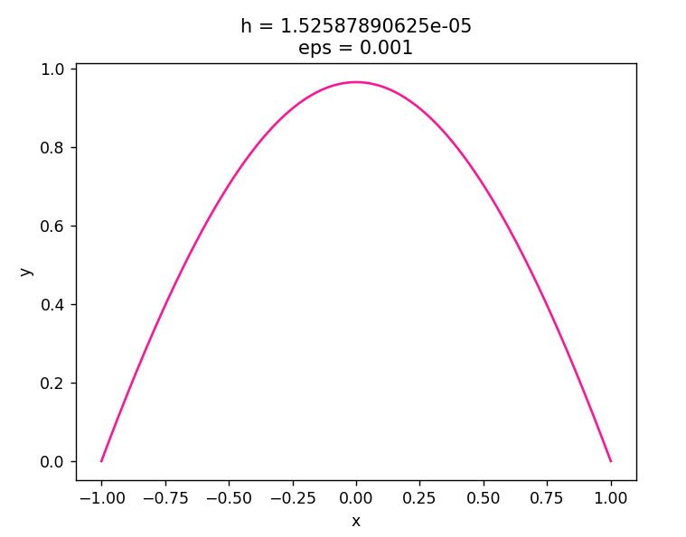

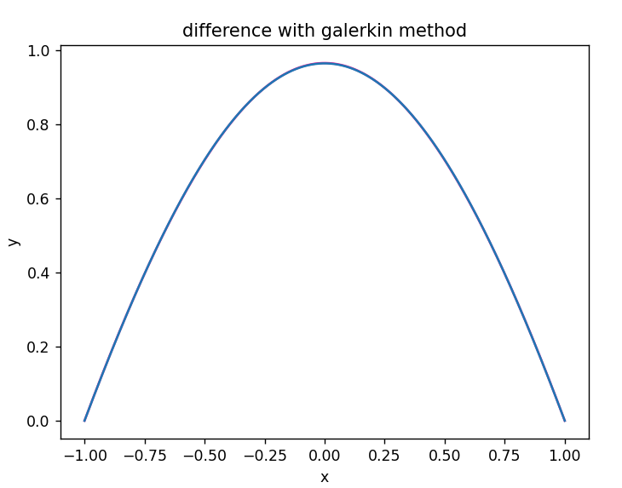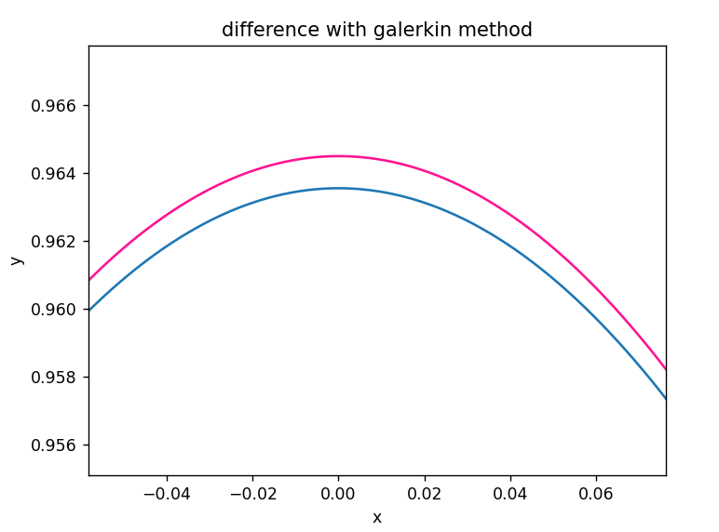

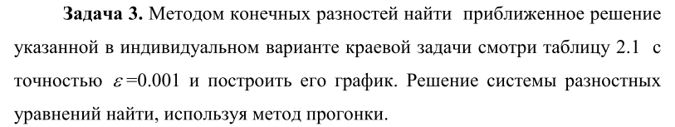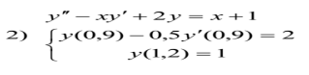

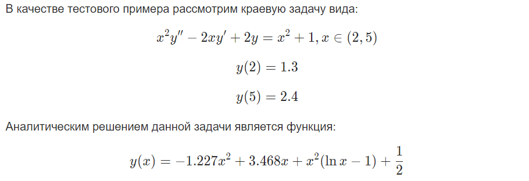

**-**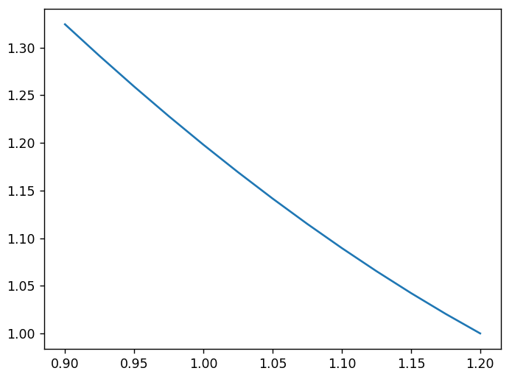

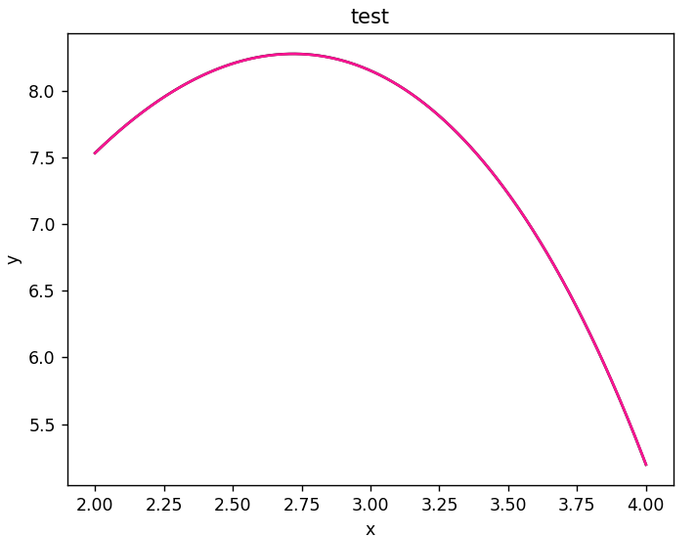

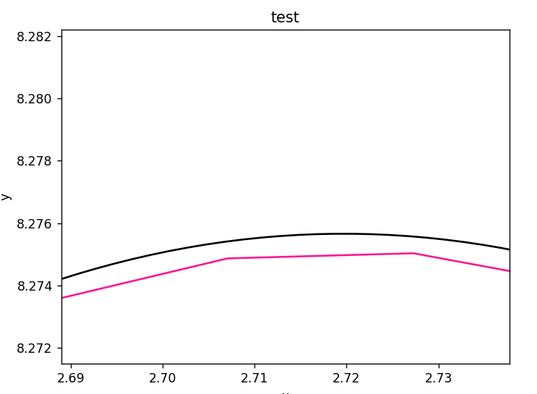

Аналитическое решение представлено чёрным цветом, а решение, полученное программой – розовым.

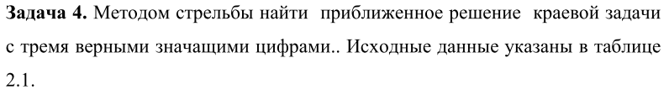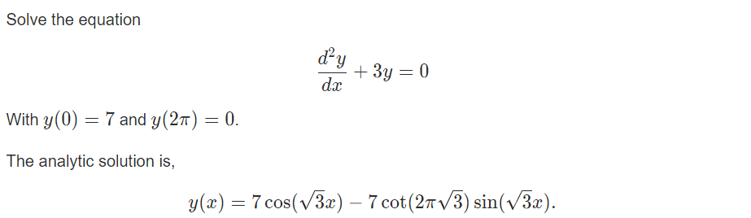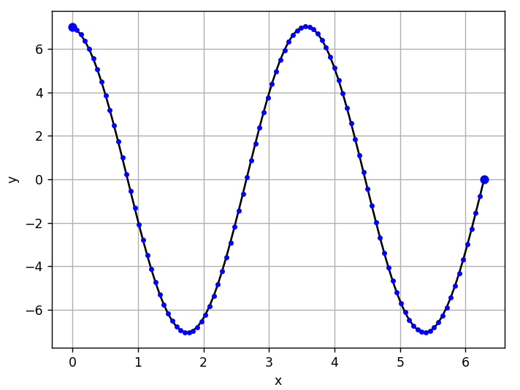

Чёрным цветом представлено аналитическое решений, а синим – точки, полученные методом стрельбы.

Для начала проведём пару вычислений для получения искомого по условии уравнения: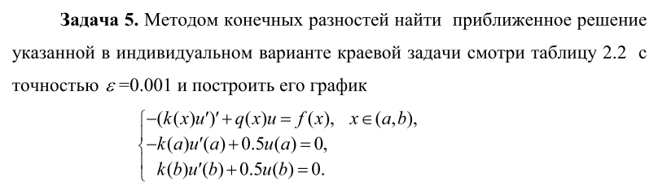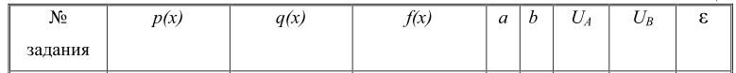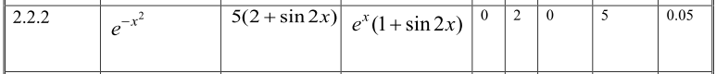

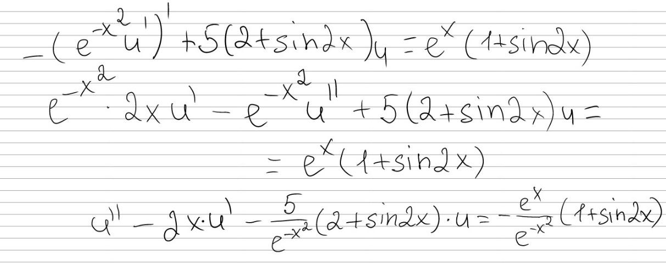

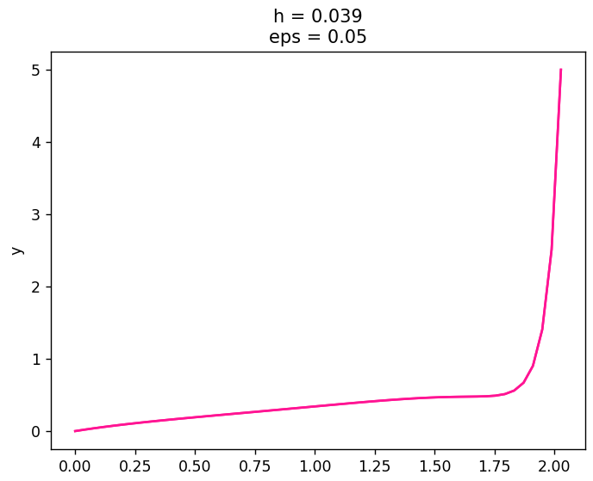

Итого получим следующие уравнение:



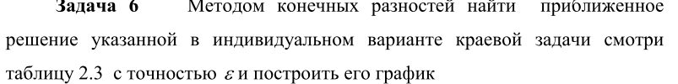

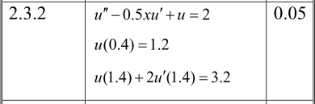

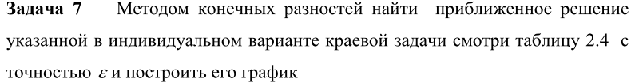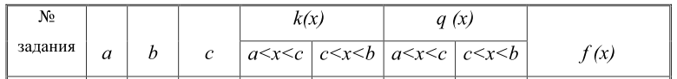

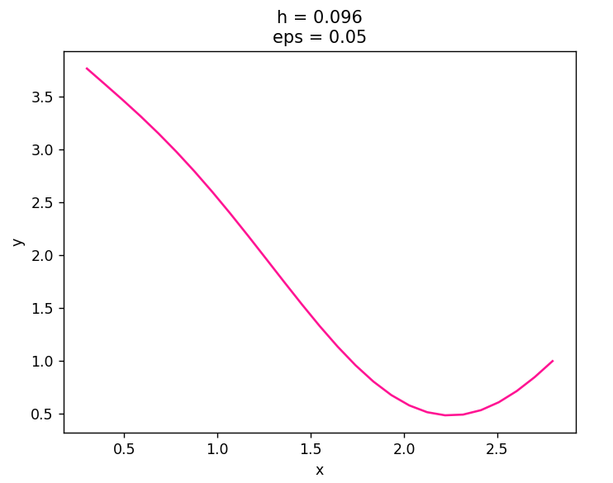

Заметим, что даже при таком маленьком шаге, краевые значения (особенно в месте разрыва) все равно имеют неточности, которые заметны невооружённым взглядом.

***Вывод:*** в данной лабораторной работе были изучены изучить метод коллокаций, наименьших квадратов и Галеркина, стрельбы и разностных аппроксимаций для решения краевых задач; была написана программа по данным методам и решены тестовые примеры.